CODE
package personalfinance;

import javax.swing.*;
import java.awt.*;
import java.awt.event.*;
import java.util.ArrayList;
import java.util.HashMap;
import java.util.List;
import java.util.Map;

public class PersonalFinanceManagerGUI {

private static List<Transaction> transactions = new ArrayList<>();
private static Map<String, Double> spendingLimits = new HashMap<>();
private static JTextArea summaryArea;
private static Map<String, Double> categorySpending = new HashMap<>();

public static void main(String[] args) {

showLoginPrompt();
}

private static void showLoginPrompt() {

JTextField usernameField = new JTextField(20);
JPasswordField passwordField = new JPasswordField(20);

JPanel panel = new JPanel();
panel.setLayout(new GridLayout(3, 2));
panel.add(new JLabel("Username:"));
panel.add(usernameField);
panel.add(new JLabel("Password:"));
panel.add(passwordField);

int option = JOptionPane.showConfirmDialog(null, panel, "Login", JOptionPane.OK_CANCEL_OPTION, JOptionPane.PLAIN_MESSAGE);

if (option == JOptionPane.OK_OPTION) {
String enteredUsername = usernameField.getText();
String enteredPassword = new String(passwordField.getPassword());

String correctUsername = "Ajishma";
String correctPassword = "mysecurepassword";

if (enteredUsername.equals(correctUsername) && enteredPassword.equals(correctPassword)) {

openMainFinanceWindow();
} else {

JOptionPane.showMessageDialog(null, "Invalid username or password. Exiting...");
System.exit(0);
}
} else {

System.exit(0);
}
}

private static void openMainFinanceWindow() {

JFrame frame = new JFrame("Personal Finance Management");
frame.setSize(600, 400);
frame.setDefaultCloseOperation(JFrame.EXIT_ON_CLOSE);
frame.setLayout(new BorderLayout());
JPanel inputPanel = new JPanel();
inputPanel.setLayout(new GridLayout(6, 2));

JComboBox<String> categoryComboBox = new JComboBox<>(new String[]{"Income", "Expense", "Savings", "Investment"});
inputPanel.add(new JLabel("Category:"));
inputPanel.add(categoryComboBox);

JTextField amountField = new JTextField();
inputPanel.add(new JLabel("Amount:"));
inputPanel.add(amountField);

JTextField descriptionField = new JTextField();
inputPanel.add(new JLabel("Description:"));
inputPanel.add(descriptionField);

JTextField dateField = new JTextField();
dateField.setText("2024-11-21"); // default date for simplicity
inputPanel.add(new JLabel("Date:"));
inputPanel.add(dateField);

JTextField spendingLimitField = new JTextField();
inputPanel.add(new JLabel("Set Spending Limit (Optional):"));
inputPanel.add(spendingLimitField);

JButton addButton = new JButton("Add Transaction");
inputPanel.add(addButton);

summaryArea = new JTextArea();
summaryArea.setEditable(false);
summaryArea.setText("Financial Summary:\n\nTotal Income: $0.0\nTotal Expenses: $0.0\nBalance: $0.0");

String[] columns = {"Category", "Amount", "Description", "Date"};
JTable transactionTable = new JTable(new Object[0][4], columns);
JScrollPane tableScrollPane = new JScrollPane(transactionTable);

frame.add(inputPanel, BorderLayout.NORTH);
frame.add(new JScrollPane(transactionTable), BorderLayout.CENTER);
frame.add(summaryArea, BorderLayout.SOUTH);

addButton.addActionListener(new ActionListener() {
public void actionPerformed(ActionEvent e) {
String category = categoryComboBox.getSelectedItem().toString();
String amountText = amountField.getText();
String description = descriptionField.getText();
String date = dateField.getText();
String spendingLimitText = spendingLimitField.getText();

try {
double amount = Double.parseDouble(amountText);

Transaction transaction = new Transaction(category, amount, description, date);
transactions.add(transaction);

if (!spendingLimitText.isEmpty()) {
double spendingLimit = Double.parseDouble(spendingLimitText);
spendingLimits.put(category, spendingLimit);
}

updateSummary();

categorySpending.put(category, categorySpending.getOrDefault(category, 0.0) + amount);

if (spendingLimits.containsKey(category) && categorySpending.get(category) > spendingLimits.get(category)) {
JOptionPane.showMessageDialog(frame, "Alert: You have exceeded your spending limit for this category!", "Spending Limit Alert", JOptionPane.WARNING_MESSAGE);
}

amountField.setText("");
descriptionField.setText("");
dateField.setText("2024-11-21");
spendingLimitField.setText("");

updateTransactionTable(transactionTable);
} catch (NumberFormatException ex) {
JOptionPane.showMessageDialog(frame, "Invalid amount. Please enter a valid number.");
}
}
});

frame.setVisible(true);
}

private static void updateSummary() {
double totalIncome = 0;
double totalExpenses = 0;
for (Transaction t : transactions) {
if (t.getCategory().equals("Income")) {
totalIncome += t.getAmount();
} else if (t.getCategory().equals("Expense")) {
totalExpenses += t.getAmount();
}
}

double balance = totalIncome - totalExpenses;

summaryArea.setText("Financial Summary:\n\n" +
"Total Income: $" + totalIncome + "\n" +
"Total Expenses: $" + totalExpenses + "\n" +
"Balance: $" + balance);
}

private static void updateTransactionTable(JTable table) {
Object[][] data = new Object[transactions.size()][4];

for (int i = 0; i < transactions.size(); i++) {
Transaction t = transactions.get(i);
data[i][0] = t.getCategory();
data[i][1] = t.getAmount();
data[i][2] = t.getDescription();
data[i][3] = t.getDate();
}

table.setModel(new javax.swing.table.DefaultTableModel(data, new String[]{"Category", "Amount", "Description", "Date"}));
}

static class Transaction {
private String category;
private double amount;
private String description;
private String date;

public Transaction(String category, double amount, String description, String date) {
this.category = category;
this.amount = amount;
this.description = description;
this.date = date;
}

public String getCategory() {
return category;
}

public double getAmount() {
return amount;
}

public String getDescription() {
return description;
}

public String getDate() {
return date;
}
}
}

OUTPUT:
USER LOGIN
Username & Password Required :
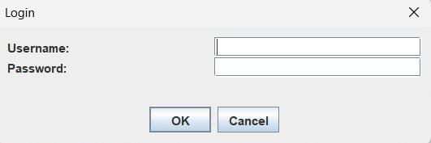

Enter Correct Username & Password:
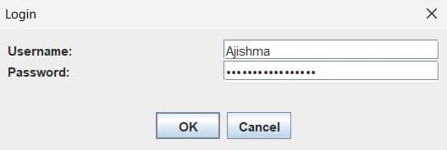

If username/ password is invalid:
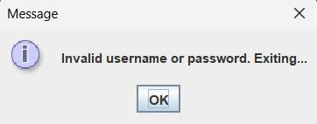

Main finance management window:

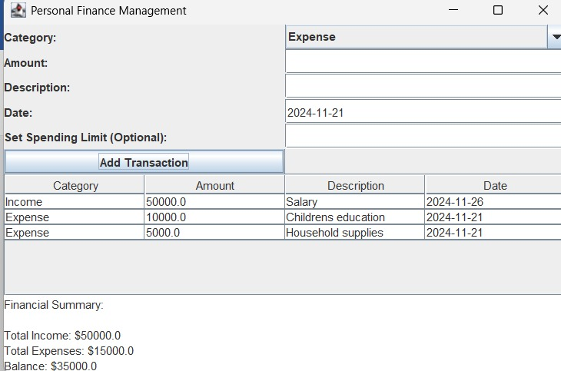

Entering a Transaction:
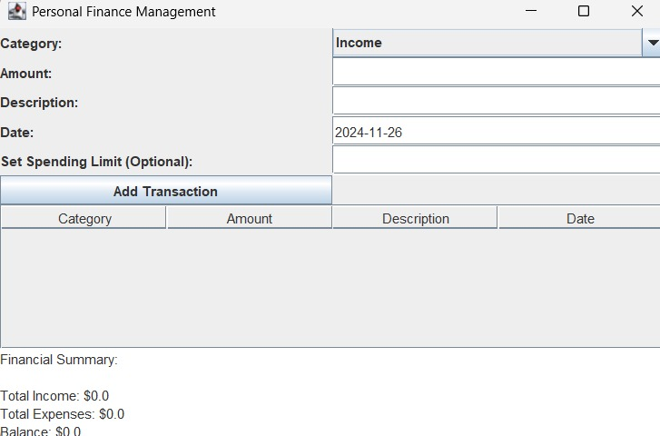

Exceeding the Spending Limit:
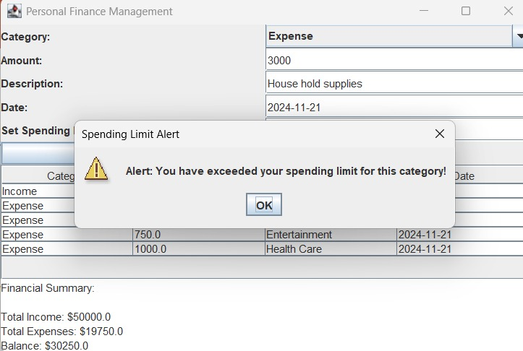

Table Update:
